GitHub Link

<https://github.com/meghraj-dewangan/ShoppyGlobewithNode.git>

* **GET /products: Fetch a list of products from MongoDB.**

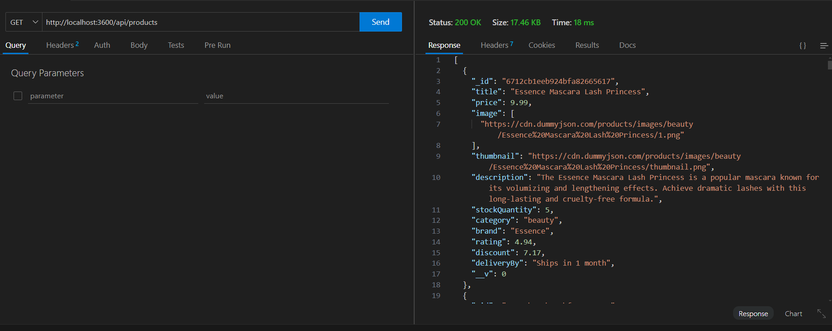

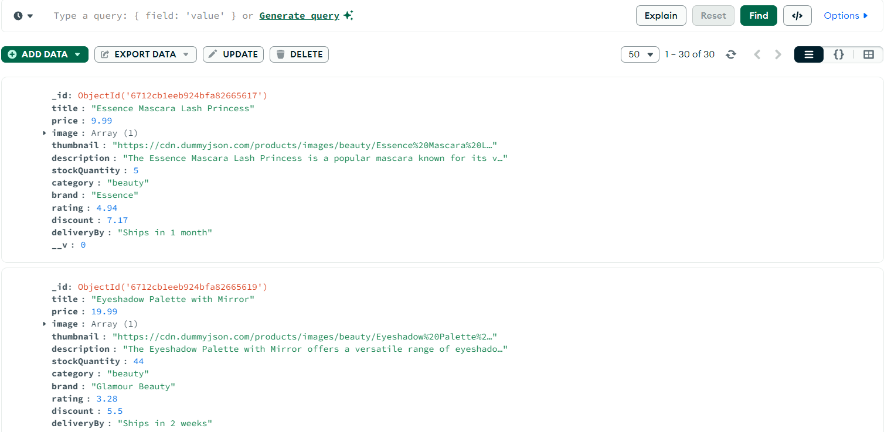

* **GET /products/ : Fetch details of a single product by its ID**

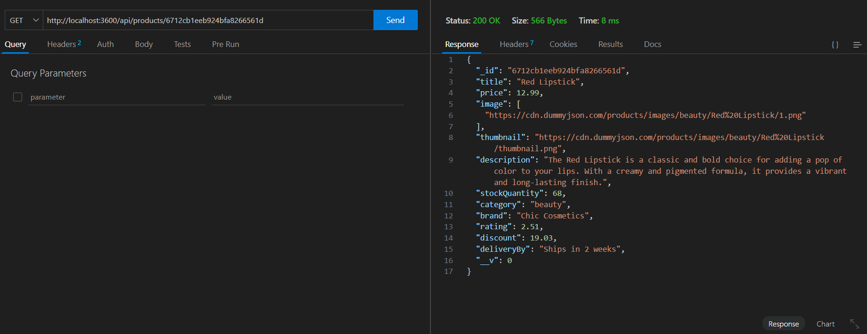

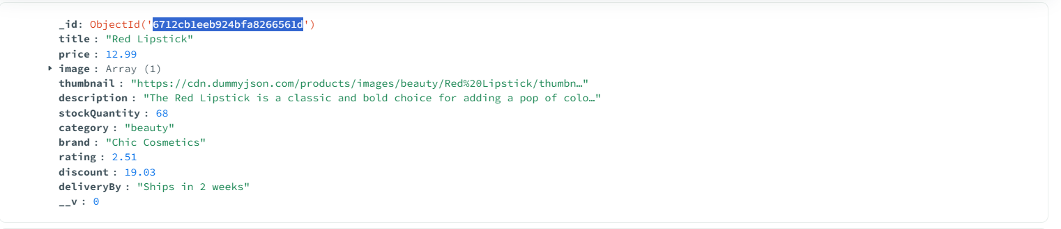

* **POST /cart: Add a product to the shopping cart**

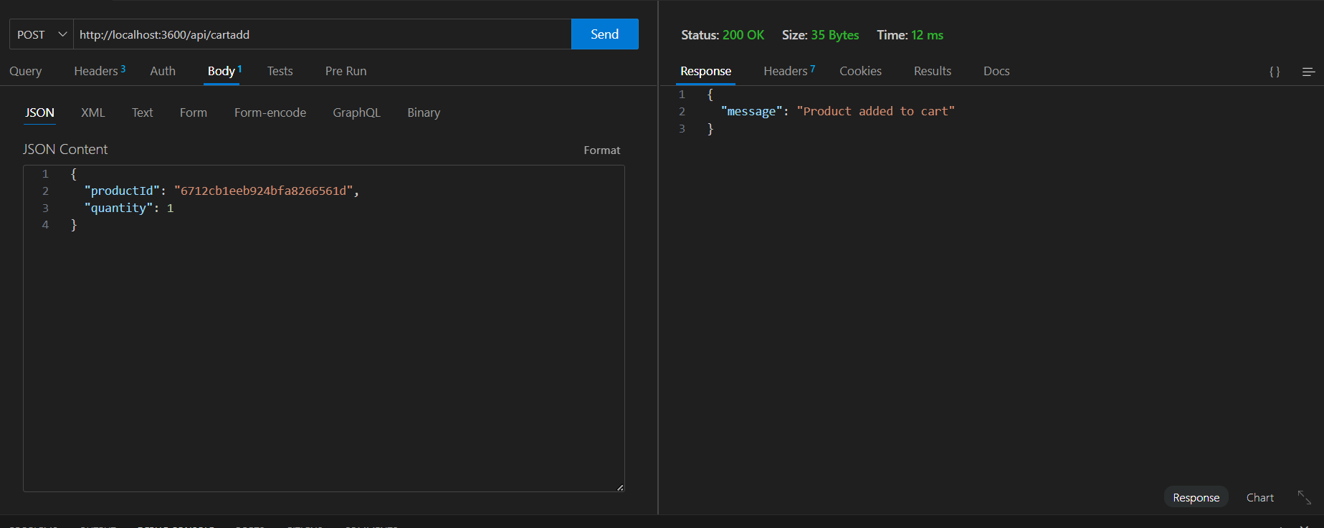

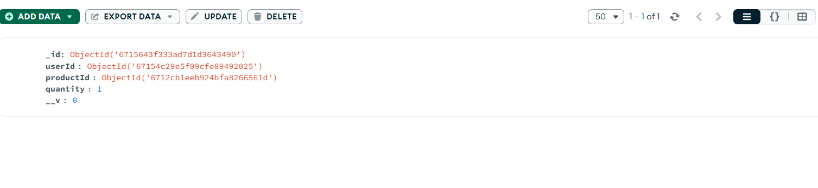

* **PUT /cart/ : Update the quantity increase of a product in the cart.**

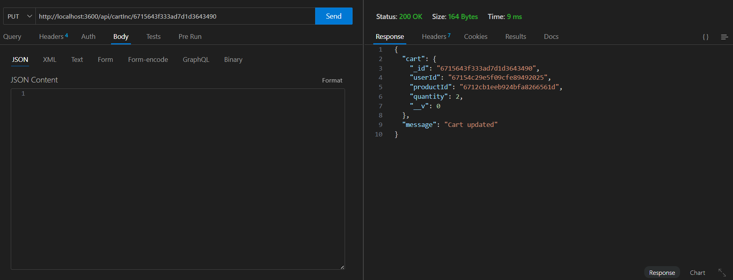

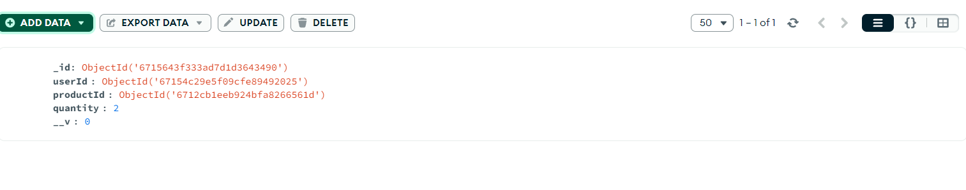

* **PUT /cart/ : Update the quantity decrease of a product in the cart.**

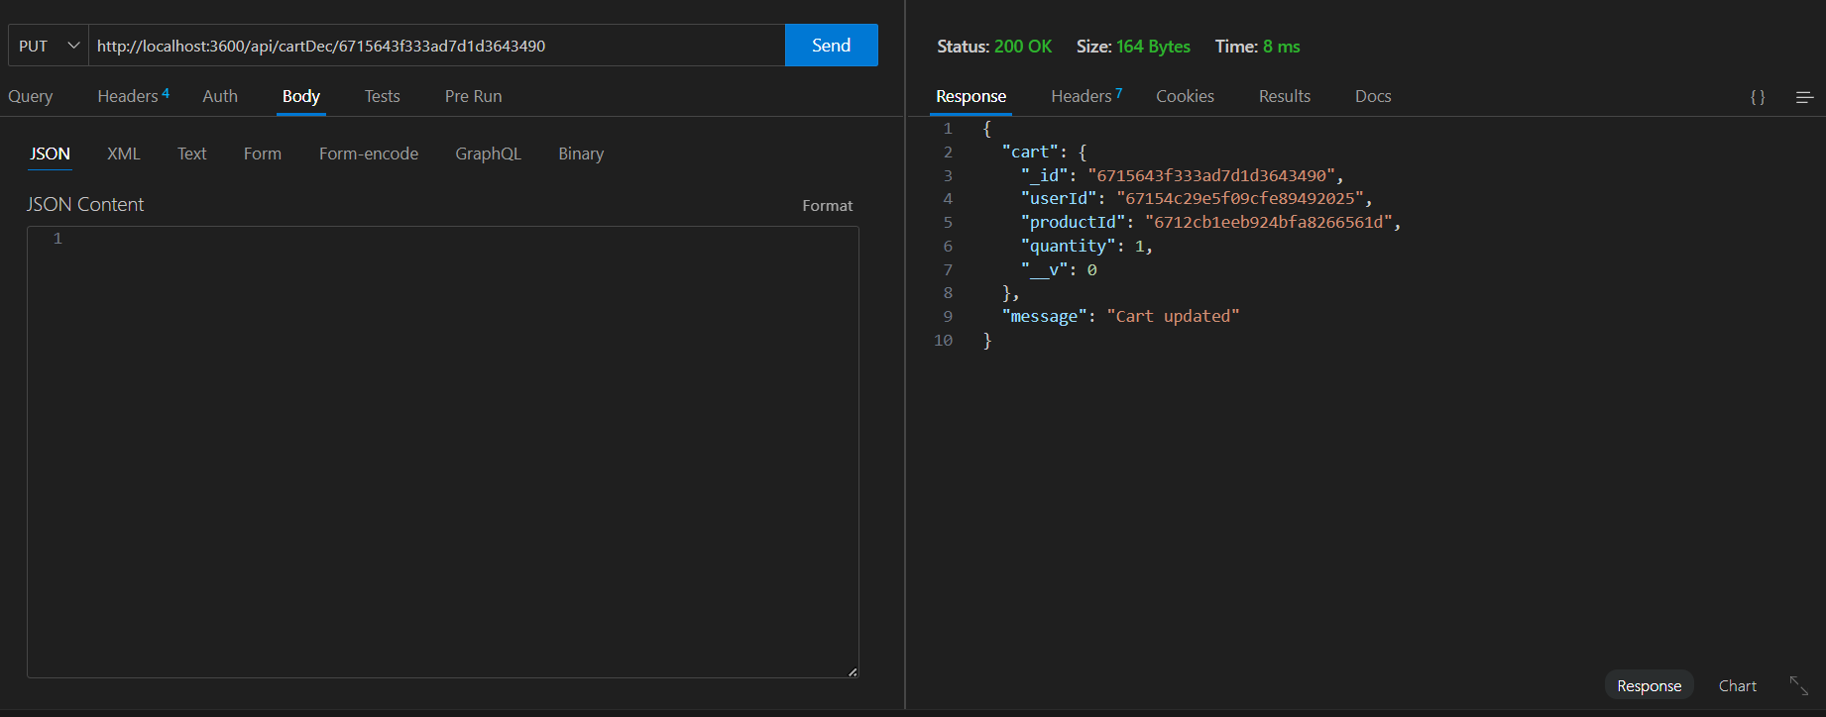

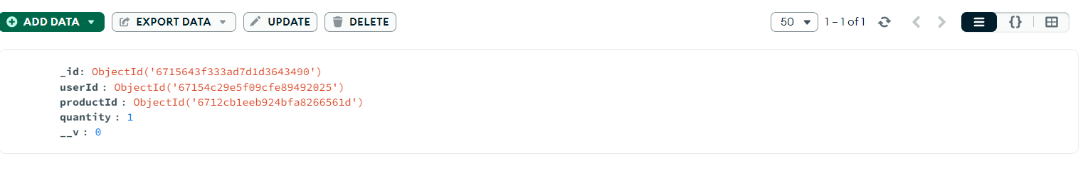

* **DELETE /clear cart/ : Remove a product from the cart.**

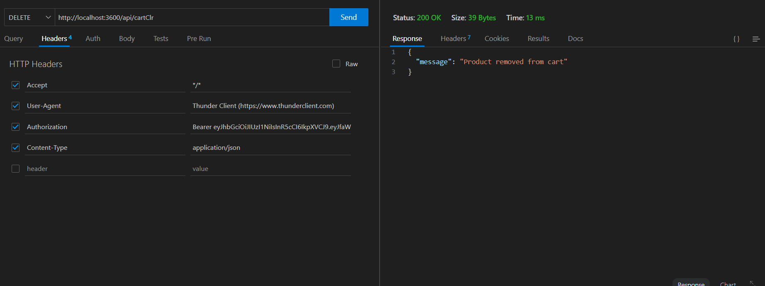

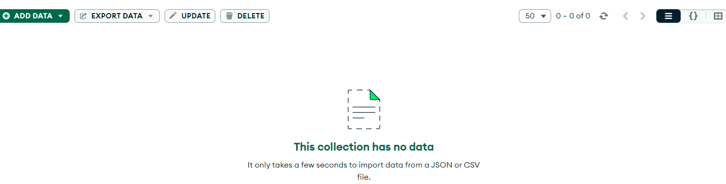

* **Post/Register:**

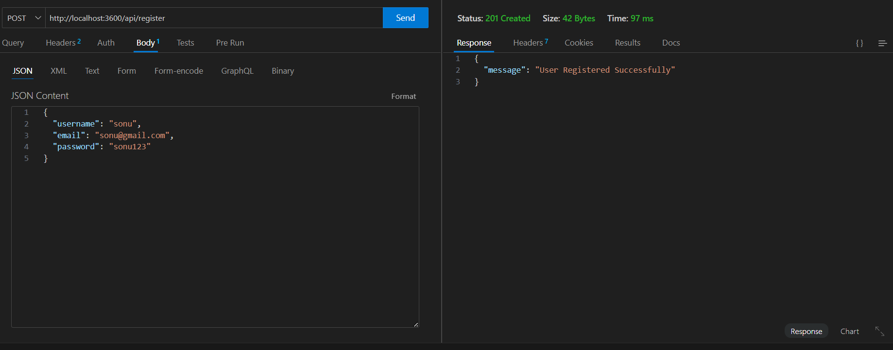

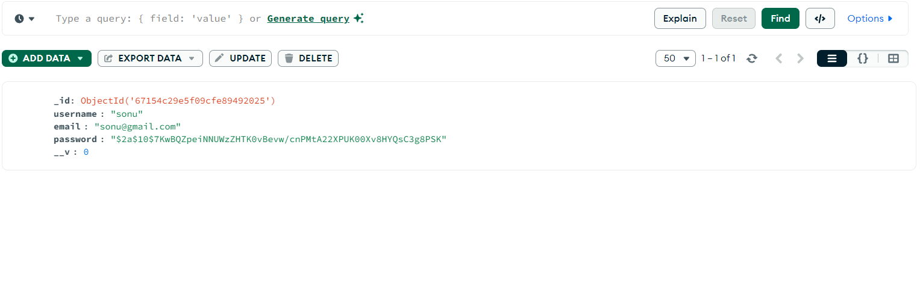

* **Post/Login:**

